Project Report

**Project Title:**

Porsche Showroom Web Site

**Project Team:**

Adnan Ansari - 05

Vishal V Naidu - 37

**Project Objective:**

To create a web site for a Porsche Showroom that runs a local back end to store information of its available cars list. A sample Bank to simulate transactions for a buyer.

**Features:**

* Exceptional page animations and style design
* Closed all back doors to the database interactions to avoid all possible exceptions, like blank data calls or incomplete data writing etc.
* Started and completed in 3.5 days

**Softwares & Technologies Used:**

* Visual Studio 2015
* Notepad++
* SQL Server 2012/14
* SQL Server LocalDB Server Emulator 2014
* ASP.NET/C# Library
* JavaScript & jQuery
* Liveweave.com (for making template designs)
* Google Drive (as the workspace Sharer)
* Chrome Remote Desktop (to have a 2-man 1-computer work session)

**Project Summary:**

The quality of service of an online vendor or an offline vendor with a web site is judged by the visual quality and the feel of the web site. The look of the site depends on the amount of page styling and dynamicity provided by making the page interactive. The feel of the site is decided by the number of times a client actually gets stuck at an infinite loader, or a crash or an unhandled exception, which is practically null for an actual website since the programmers spend hours to clean up the back end and leave no strings untied. The same course has been upheld in this mini project and thus the site’s submission-build is free of all possible errors.

**Screenshots:**

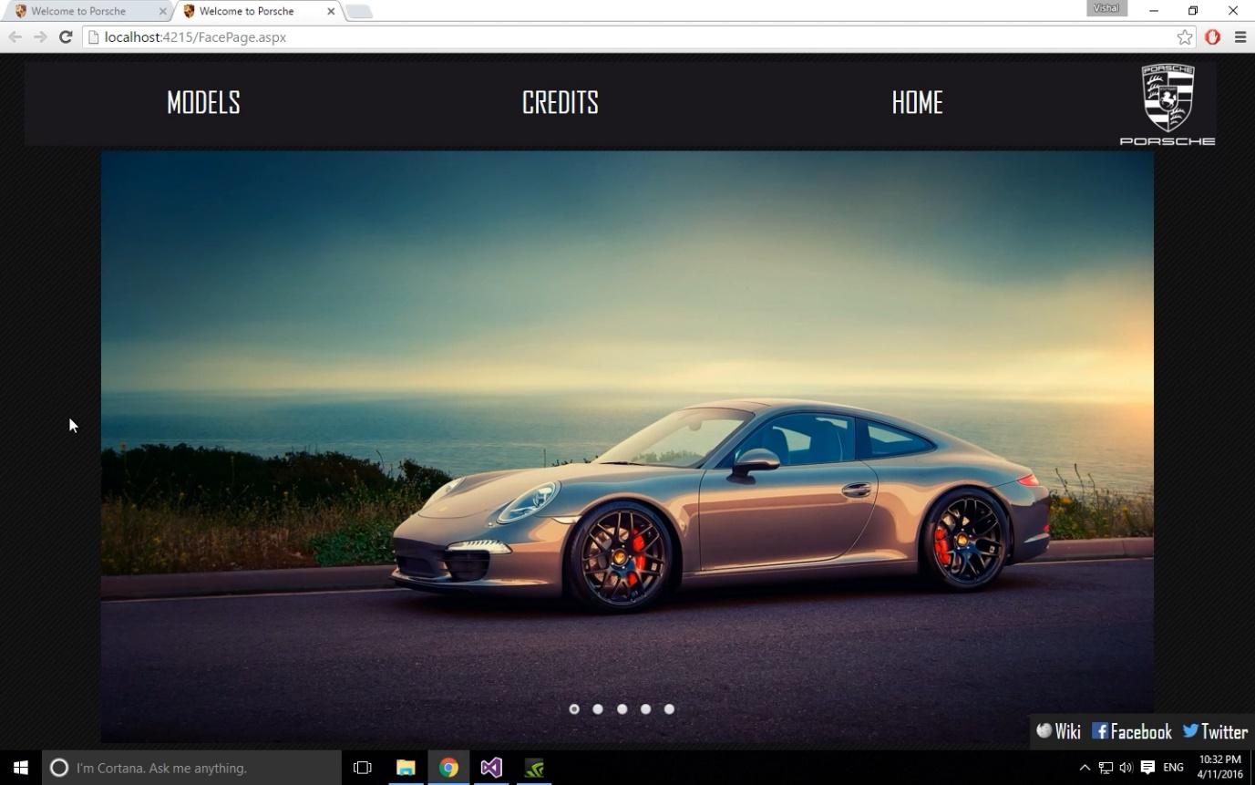

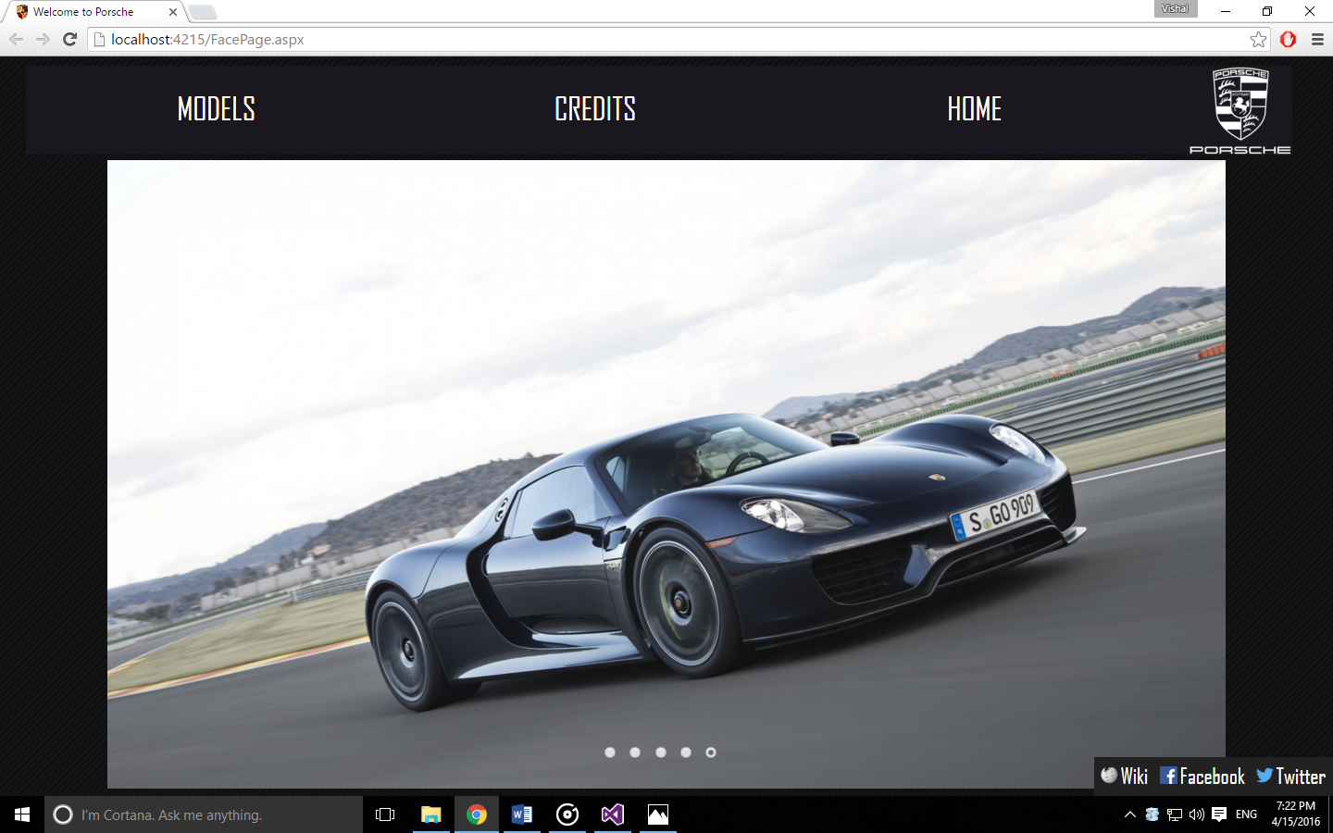

A home page that contains a face-off image (set of 5) that slide and change in a smooth transition of loop time 4 seconds

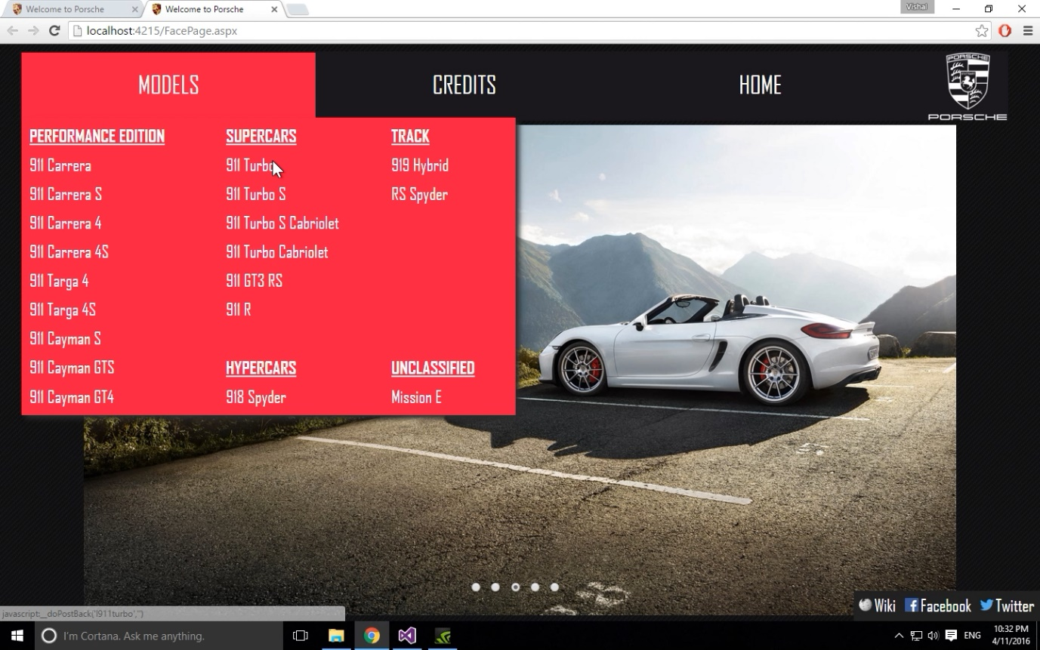

A dynamic drop down menu, containing a list of cars available in the showroom. Each name is an ASP link button which is rigged to redirect to the main contents page

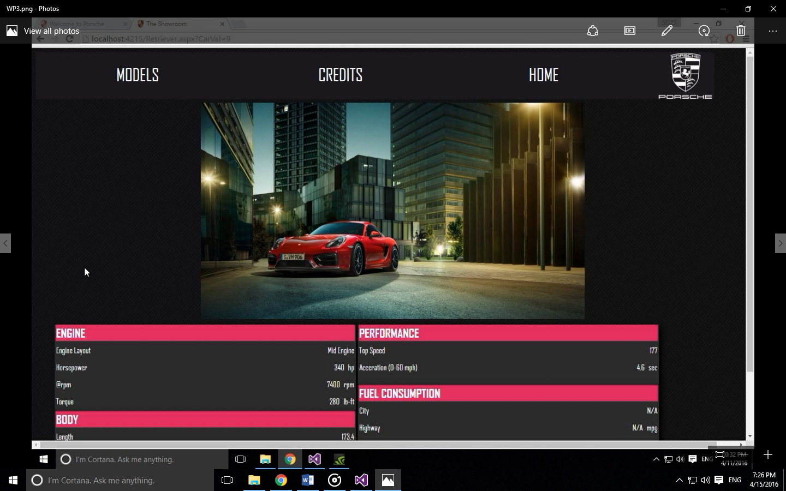

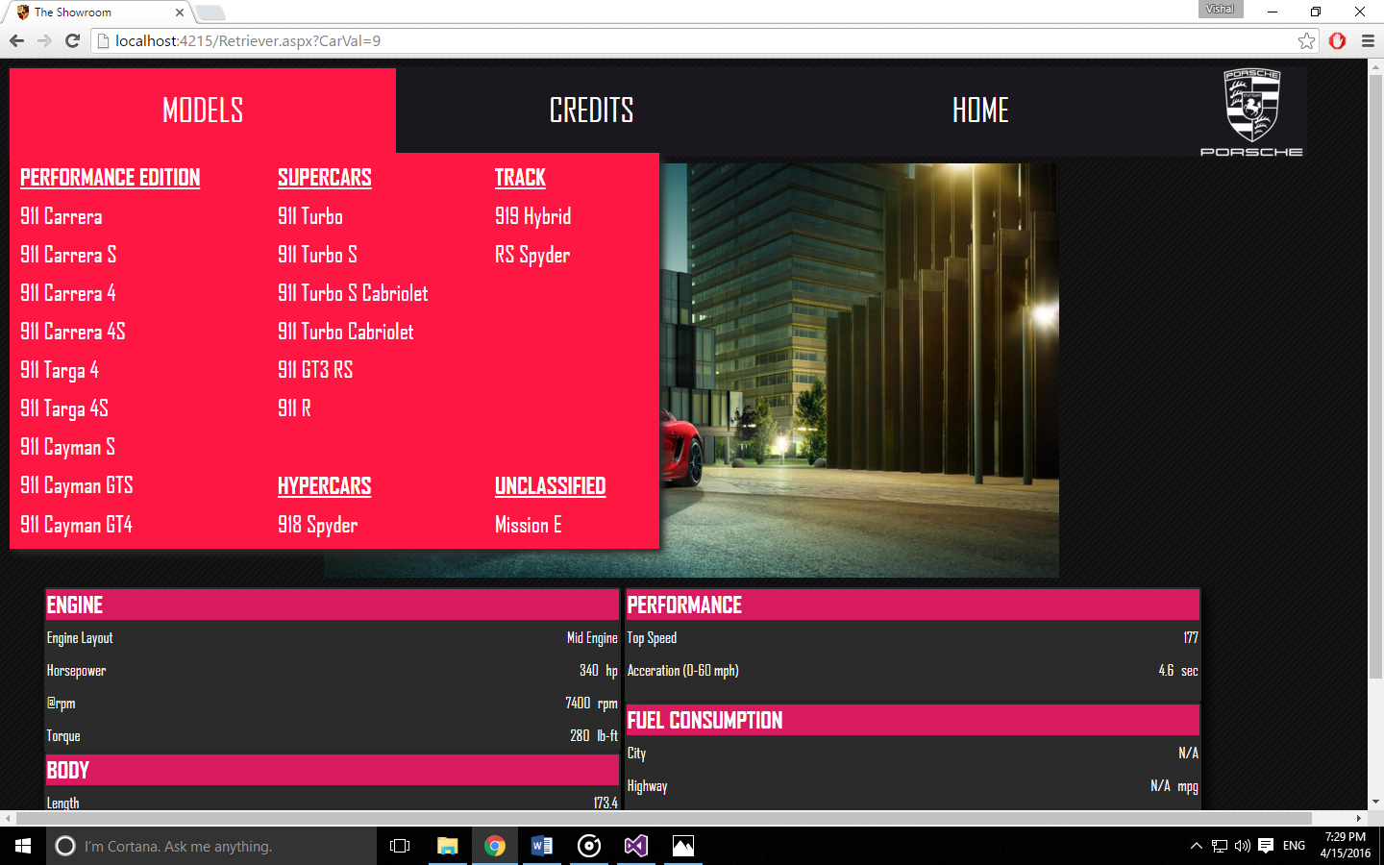

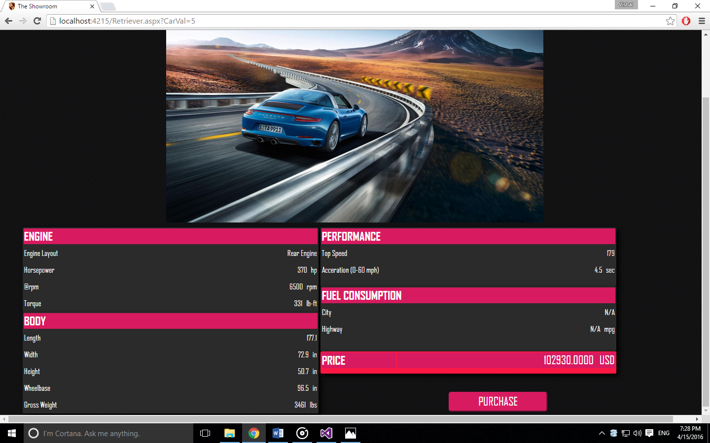

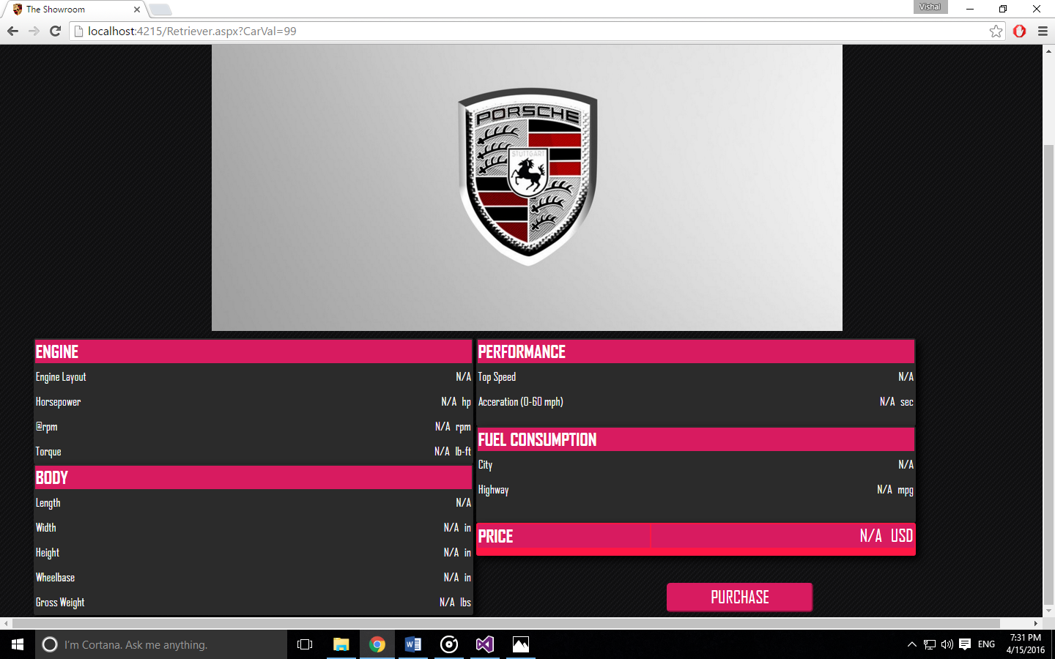

The contents page looks for a model ID that would have been sent from any page that uses the signature navigation tab. One such tab on this page is used to launch a self-redirect to load new car data from the database each time the page loads. A backup blank data handle and a backup image to handle calls to car data requests that are not available on the database yet. The content page redirects to the local bank page to opt for the transaction. If the client has no account on the bank, a link to another page is made available to create a new account and to avail a new account number which can be used for further transactions.

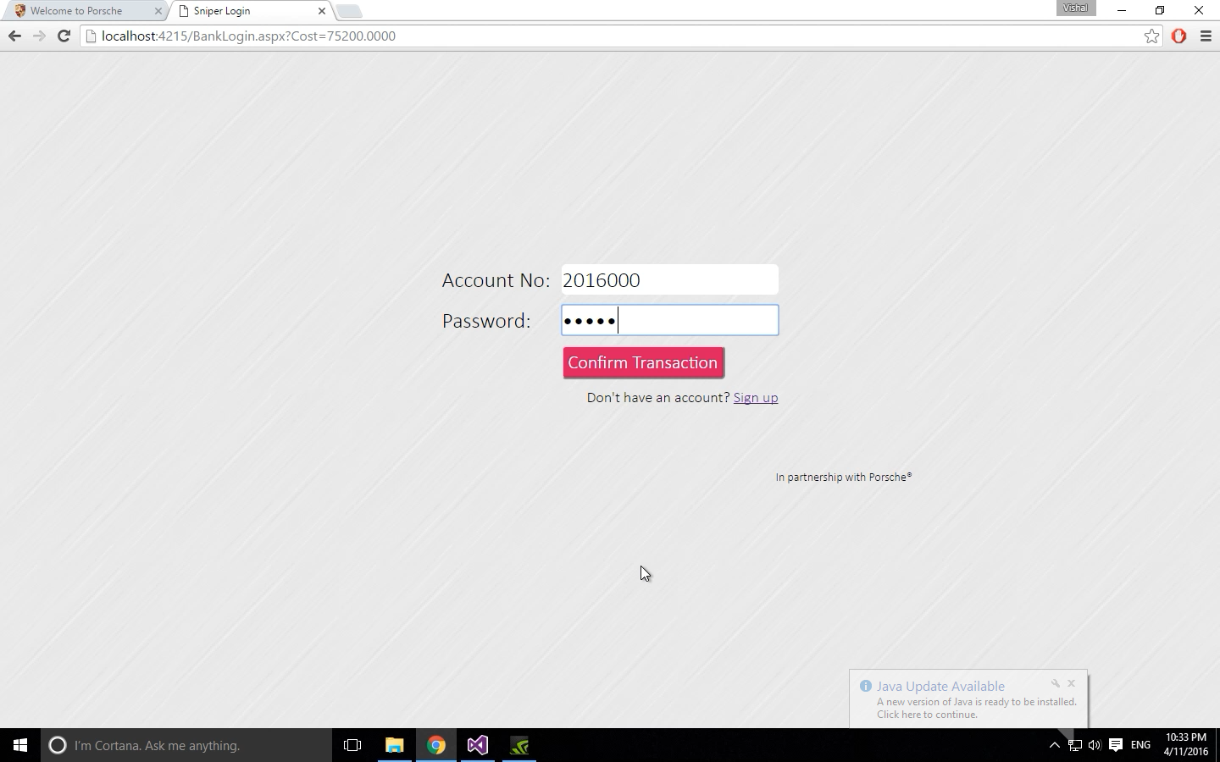

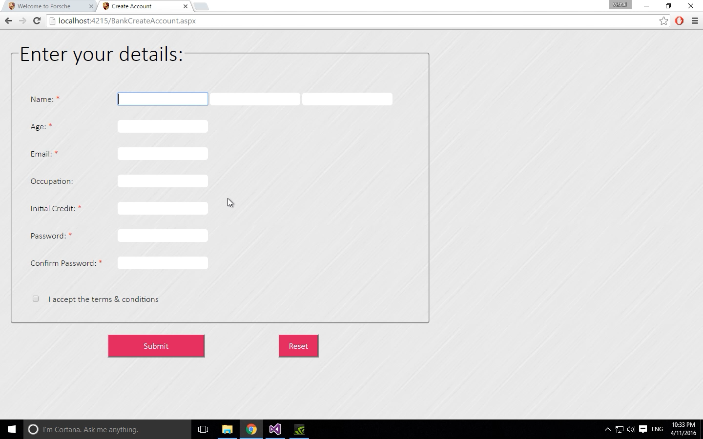

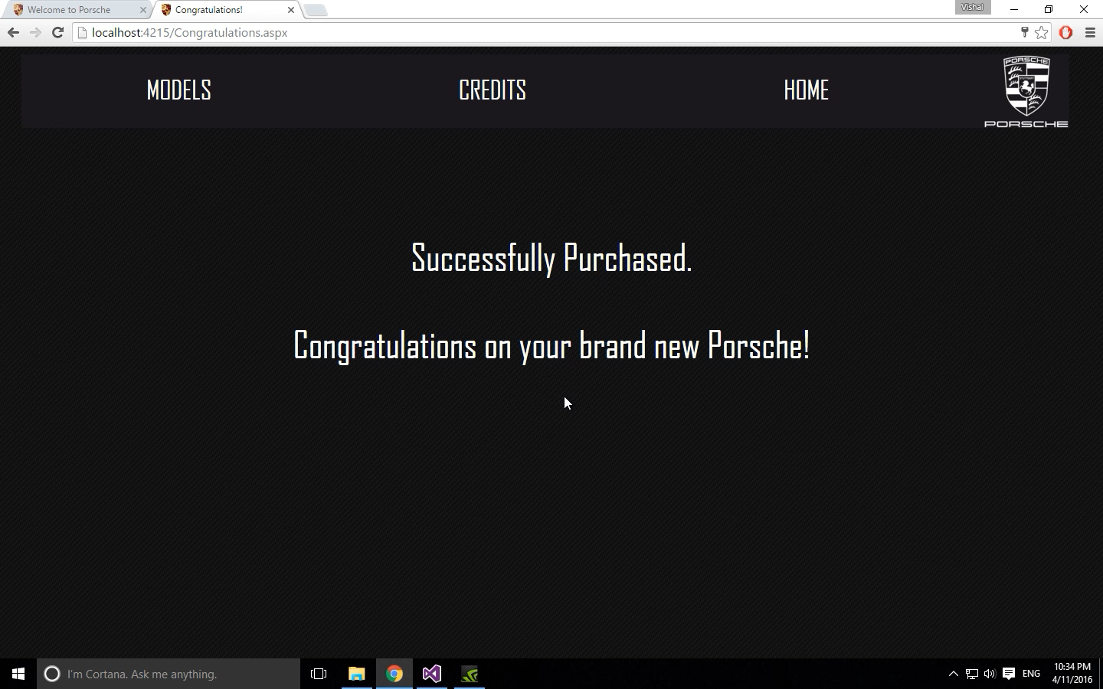

**Database Screenshots:**

